Warning - Adaptive Cruise Control – CGEA1.3

Functional Description

The purpose of the Adaptive Cruise Control Warning feature is to the driver of Cruise Control ON/OFF/Override events, speed and following distance (gap) settings, Driver Intervene warnings, or system malfunction information.

The Adaptive Cruise Control Chime feature correlates the AccMsgTxt_D_Rq, AccTGap_D_Dsply and Veh_V_DsplyCcSet signals from the ACCM, configuration information, the English/Metric status, and the operational mode to display the appropriate warning or INFO display in the message center and/or sound the appropriate chime.

Interfaces

Interface Context Diagram (I/O Block Diagram)
Figure 1 Adaptive Cruise Control Warning Context Diagram

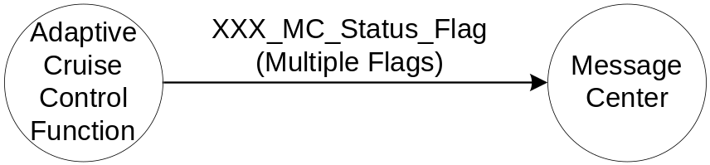

- See Adaptive Cruise Control Function Section for details specific to this function.

Revision History

SPSS Module Revision History
Revision Level | Name | Change Description | Date
1.0 | V. Patel | Updated for CGEA 1.3 based on CGEA STSS v1.0 | 4/13/2010

